SIT- 232 OBJECT- ORIENTED DEVELOPMENT
STUDENT ID: 224001588

QUESTION3:
Find all existing issues with the code snippets presented below. It is highly important to try working this out on paper by tracing through the statements and then input the code into your IDE. Run it to see if you are correct, and then see if you can fix the code.

SNIPPET 1:
int number = 50;
if (number == 50) ; {
Console.WriteLine(“Number is 50”);
}

ISSUE:
The main existing issue in this code snippet is the presence of an extra semicolon ( ; ) after the ‘if’ statement. This semicolon terminates the ‘if’ statement before it even executes, which makes it an empty or useless statement.
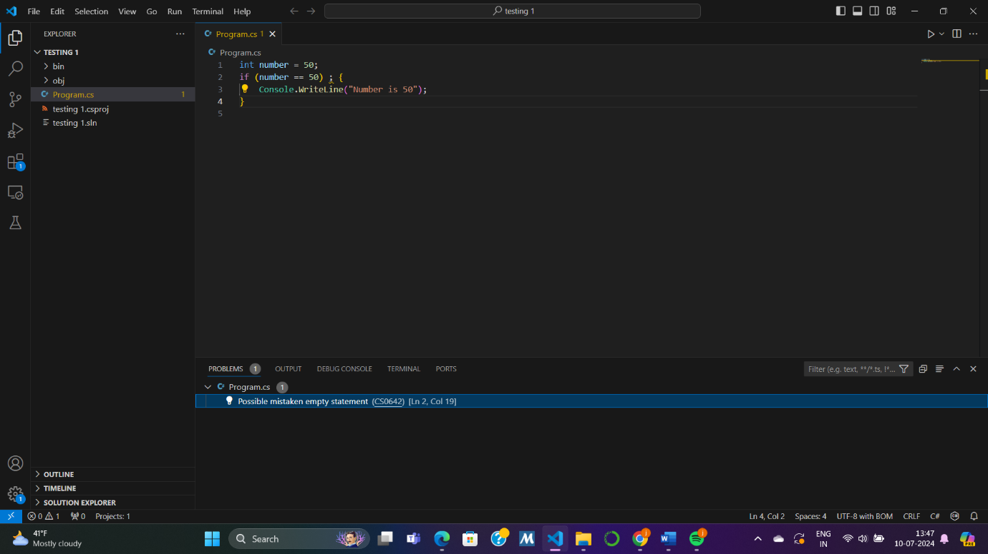
CORRECT CODE:
int number = 50;
if (number == 50) {
Console.WriteLine("Number is 50");
}
In this corrected version, the message "Number is 50" will only be printed if number is equal to 50.

SNIPPET2:
int number = 60;
if (number >== 50 and number <== 100) {
Console.WriteLine(“Number is more than or equal to 50 and less than or equal to 100”);
}

ISSUE:
Syntax error:
This snippet is using ‘>==’ and ‘<==’ for representing ‘greater than or equal to’ and ‘less than or equal to’ which are not valid in c#.
Instead, it could use <= and >=
Another error is that this code snippet uses “and” operator which is again invalid in c#. instead, we can use ‘ &&’.
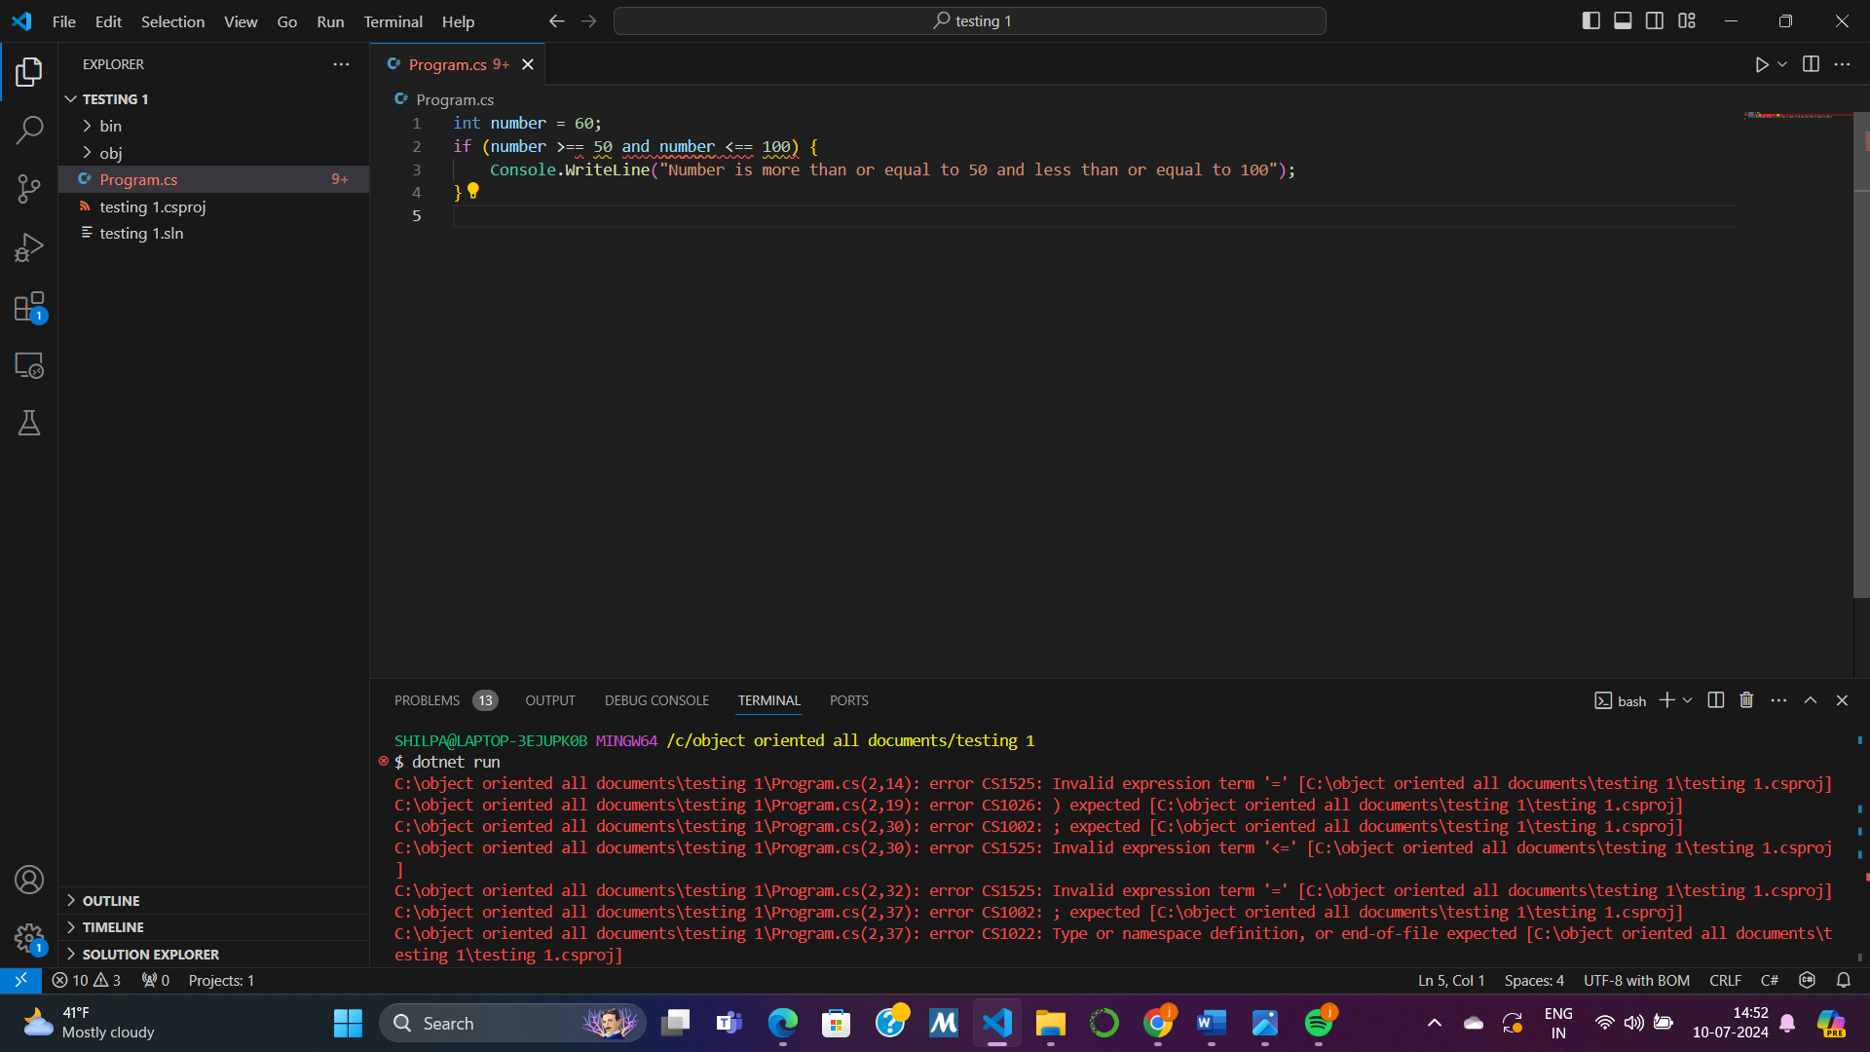
CORRECTED CODE:
int number = 60;
if (number >= 50 && number <= 100) {
Console.WriteLine("Number is more than or equal to 50 and less than or equal to 100");
}
In this corrected version, the condition properly checks if number is between 50 and 100, inclusive, and prints the message accordingly.

SNIPPET3:
public class Score {
public static void main(String[] args) {

double score = 40; if score > 40{
Console.WriteLine("You passed the exam!");
} else score < 40{
Console.WriteLine("You failed the exam!");
}
}
}

ISSUES:
The “IF” condition must be enclosed in parentheses.
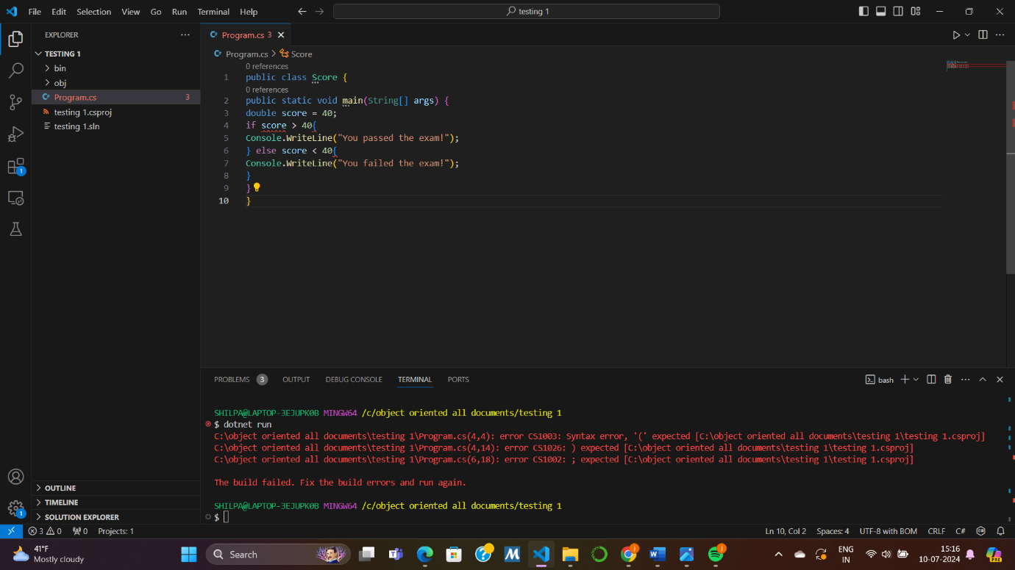
CORRECTED CODE:
public class Score {
public static void Main(string[] args) {
double score = 40;
if (score > 40) {
Console.WriteLine("You passed the exam!");
} else {
Console.WriteLine("You did not pass the exam!");
}
}
}
SNIPPET4:
Switch (n) {
case 1: Console.WriteLine(“The number is 1”);
case 2: Console.WriteLine (“The number is 2”); break; default: Console.WriteLine (“The number is not 1 or 2”); break; }
ISSUE:
There are a few issues with this given code snippet
- The switch statement should be in all lowercase i.e. ‘switch’ .
- Each of the case statement should be followed by a ‘break’ to prevent fall through or say that once the condition is met , it exits the ‘switch’ statement.
- The variable ‘n’ is not declared.

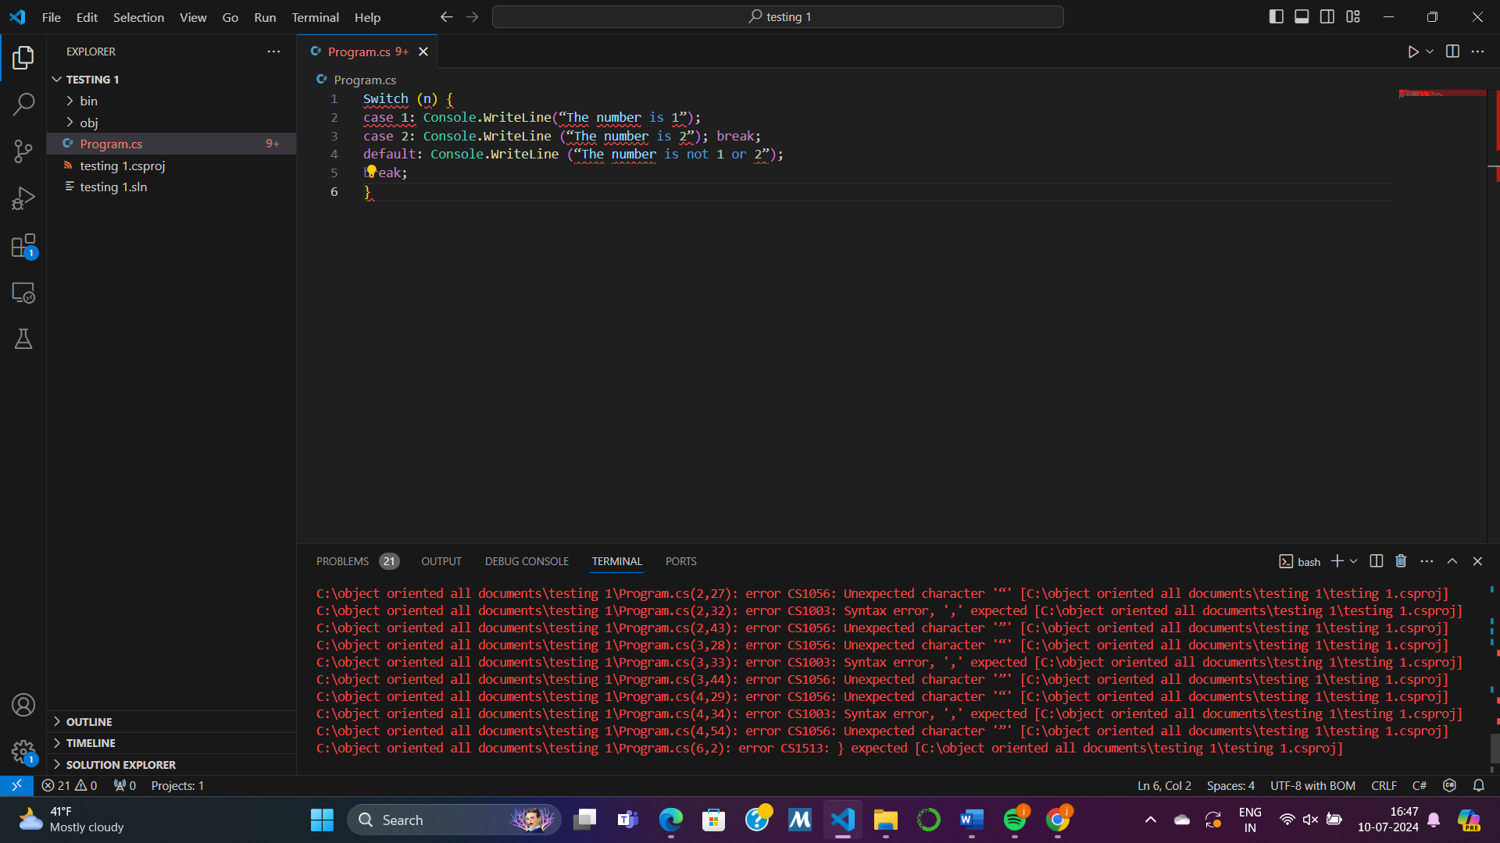
CORRECTED CODE:
Int n =1;
switch (n) {
case 1:
Console.WriteLine("The number is 1");
break;
case 2:
Console.WriteLine("The number is 2");
break;
default:
Console.WriteLine("The number is not 1 or 2");
break;
}
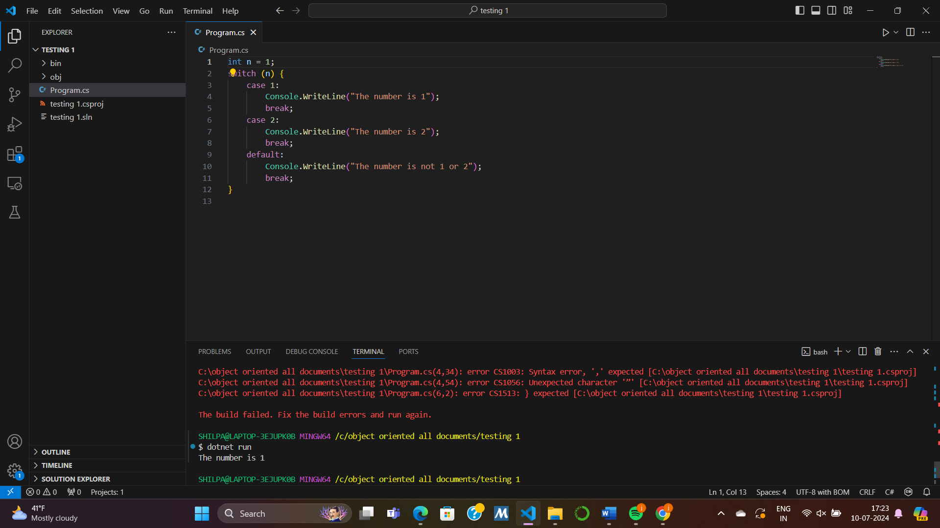
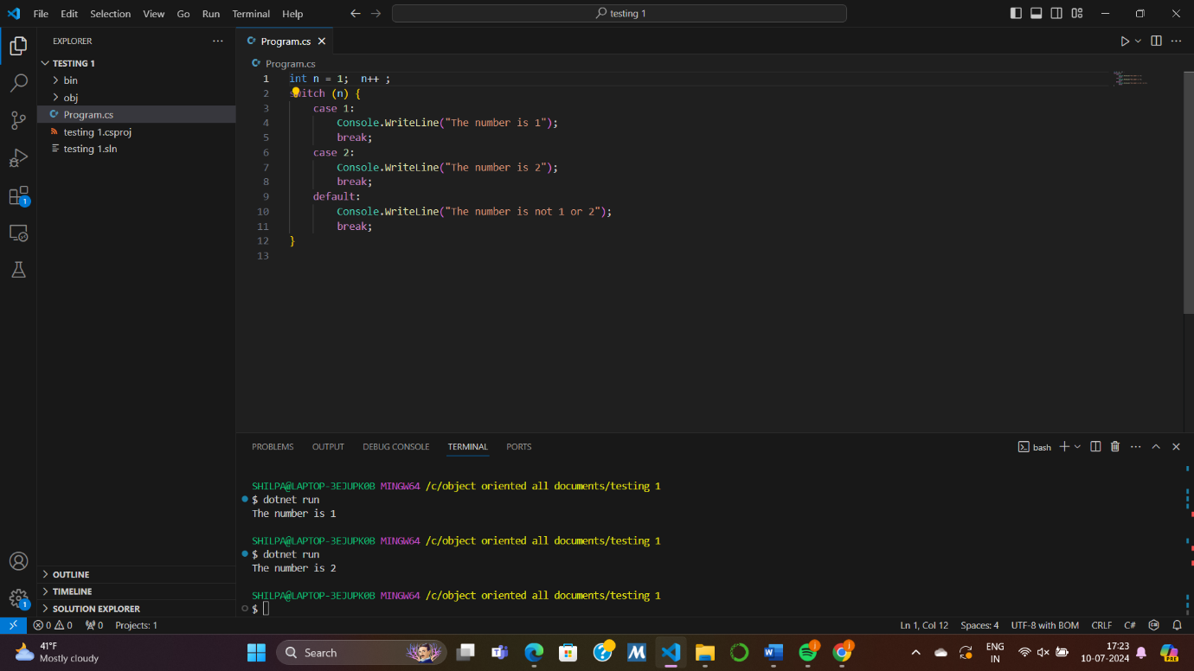
Furthermore, we can declare ‘n’ as per our requirements to use it in the code.

SNIPPET5:
switch (n) {
Case 1: Console.WriteLine (“A”); break;
case2: Console.WriteLine (“B”); break;
Default: Console.WriteLine (“C”); break;
}

ISSUE:
There are a few issues with this code
- Case sensitivity :
The written “Case” and “case2” in line 2 and 3 should be written as “case 1” and “case 2”.
The written “Default” in line 4 should be written as “default”.

